*Available online at: www. ijmt.ir*

**Paper Title (Times New Roman B 16)**

(Times New Roman 10)

**First Author Full Name1, Second Author Full Name2*(Times New Roman B 13)**

(Times New Roman 10)

*1 First Author Job Title, Working Place; email address (Times New Roman I 11)*

*2 second Author Job Title,Working Place; email address (Times New Roman I 11)*

|  |  |  |
| --- | --- | --- |
| **ARTICLE INFO** |  | **ABSTRACT** |
| *Article History:*  Received….  Accepted ….  Available online …. | The abstract should include the purpose, design/methodology/approach, findings, research limitations/implications and originality/value. Abstract of the paper must be between 250-300 words (Times New Roman 11). |
| *Keywords:*  Times New Roman 9  Times New Roman 9  Up to 5 Phrases |

**1. Introduction**

The paper size for manuscripts is A4 with 1.5 cm margins from all sides and should be written in two-column format. Each column width is equal to 8.5 cm and spacing is equal to 1 cm. Authors can use the present template for configuring their papers.

Fonts for different parts of the paper are in Times New Roman are as follow:

* Title: 16pt B
* Author(s): 13pt B
* Address: 12pt I
* Keywords: 9pt
* Abstract: 11pt
* Section Headings: 12pt B
* Subsection Headings: 11pt B
* Main text: 11pt
* Caption of tables and figures: 9pt B
* Tables: 9 pt
* Refrences: 11 pt
* Space before equations, between captions and tables, between captions and figures: 5 pt
* Space before tables, figures, titles, subtitles, etc: 10 pt

Length of the full paper must not exceed 12 pages. Papers must be prepared using Word 2007 or Word 2010 software and Both WORD-DOCX and PDF formats of the papers have to be submitted to the journal website ([www.ijmt.ir](http://www.ijmt.ir)). In WORD-DOCX formats of the papers, the author list must not be omitted.The papers that are not prepared according to the guidelines will not be processed and reviewed.

References must be represented as well as “[]” e.g. [7] in the main text. They must be numbered in order of their appearance.

**2. Governing Equations**

Equations start from the far left of the row. They are numbered consecutively. The equation numbers must be bracketed and placed opposite to the equation on the far right of the line.

All formulations and notations must be written as an equation (or by MathType). Equation must be mentioned in the text as Eq.(1), All variables in equations must be defined.

A correct sample:

(Times New Roman 5)

 (1)

(Times New Roman 10)

where in Eq.(1)  stands for pressure. It is equal to 100  in the case of…

An incorrect sample:

V2-V02=2ad (2)

Where in Eq.(2) V stands for velocity. It is 10 m/s in the case of…

**3. Figures and Tables**

Number all tables and figures according to their appearance.

**3.1. Figures**

Figure 1. Free surface deformation around a barge with a forward speed of 5 m/s;

(a):Numerical simulation, (b): Experiment

(Blank Times New Roman 10)

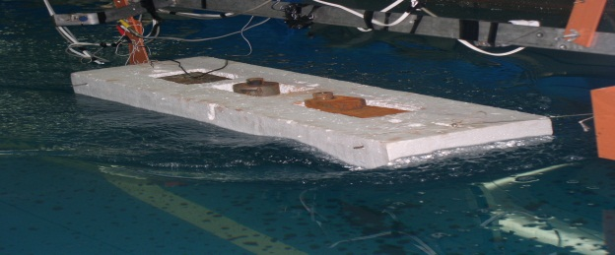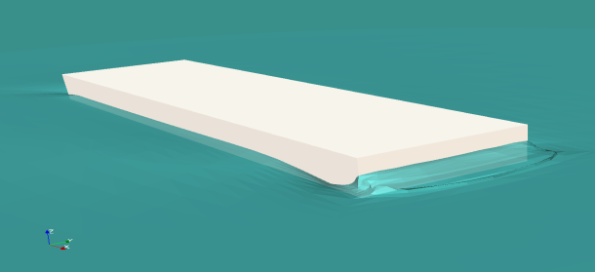

(a)

(b)

Figures must be numbered and the caption of the figures must be noted at the bottom of the figure. All the legends and the numerical values on the axes of

the curves must be clear and readable. Figures must appear where (or as close as to where) they are first

mentioned in the text. They must be referred in the text as Figure 1 (e.g.: It is obvious from Figure 1 that…). Diagrams must be also represented with clear axes, fonts, without background, with distinguishable lines in a black and white version.

**3.2. Tables**

Tables must be numbered and the title of the table must be placed on the top of the table with the footnotes on the bottom. Tables must appear where (or as close as to where) they are first mentioned in the text. They must be referred in the text as Table 1. (e.g..: Catamaran characteristics are presented in Table 1). Table must be constructed from simple lines with hidden vertical rules and no background.

(Blank Times New Roman 10)

**Table 1. Simulated catamaran characteristics**

|  |  |
| --- | --- |
| **Characteristic** | **Value** |
| Length | 12.3 [*m*] |
| Width | 4.6 [*m*] |
| Draft | 0.95 [*m*] |
| Mass | 17850 [*kg*] |
| Vertical center of gravity | 0.45 from bottom[*m*] |
| Longitudinal center of gravity | 3.81 from aft [*m*] |
| Thruster position | 0.65 from bottom [*m*] |
| Block coefficient (CB) | 0.33 [-] |

(Blank Times New Roman 10)

**3.3. Pictures**

They must the quality of 300dpi.

**4. Results and Discussion**

Results of the work and discussions are presented here.

**5. Conclusions**

Main conclusions of the paper must be put here.

**Acknowledgment (Optional)**

Acknowledgments are written here.

**List of Symbols (Optional)**

The list of symbols comes after the acknowledgment and before references. The English symbols come first followed by the Greek symbols. Both must be typed in alphabetical order and separated.

|  |  |
| --- | --- |
|  | Modulus of elasticity [] |
|  | Stiffness [] |
|  | Acoustical pressure [] |
|  | Amplitude of the excitation plane wave [] |
|  | Blocked pressure [] |

**8. References**

References must be numbered and be listed in the list of references in the order they were referred to in the text.

Complete details of the references will appear in the list of references. Just mention those references which were mentioned in the paper.

1- Brown, D.L., Cortez, R. and Minion, M.L., (2001), *Accurate projection methods for the incompressible Navier-Stokes equations*, Journal of Computational Physics, Vol.168(5), p.464-499.

2- Hosini, M. and Mohamadi, N., (2006), *Simulation of surface piercing foil*, Journal of Marin Engineering, Vol.2, p.12-20. (In Persian)

3- Patankar, S.V. and Spalding, D.B., (1972), *A calculation procedure for heat, mass and momentum transfer in three dimensional parabolic flows*, International Journal of Heat and Mass Transfer, Vol. 15, p.1787-1790.

4- Xing-Kaeding, Y., (2004), *Computation of turbulent free-surface flows around ships and floating bodies*, PhD thesis, Teschnichen Universitat Hamburg-Harburg.

5-Su, X., Sheng, C. and Allen, C.B., (2011), *An Efficient Mesh Deformation Approach based on Radial Basis Functions in Unstructured Flow Solver,* 29th AIAA Applied Aerodynamics Conference, Honolulu, HI.